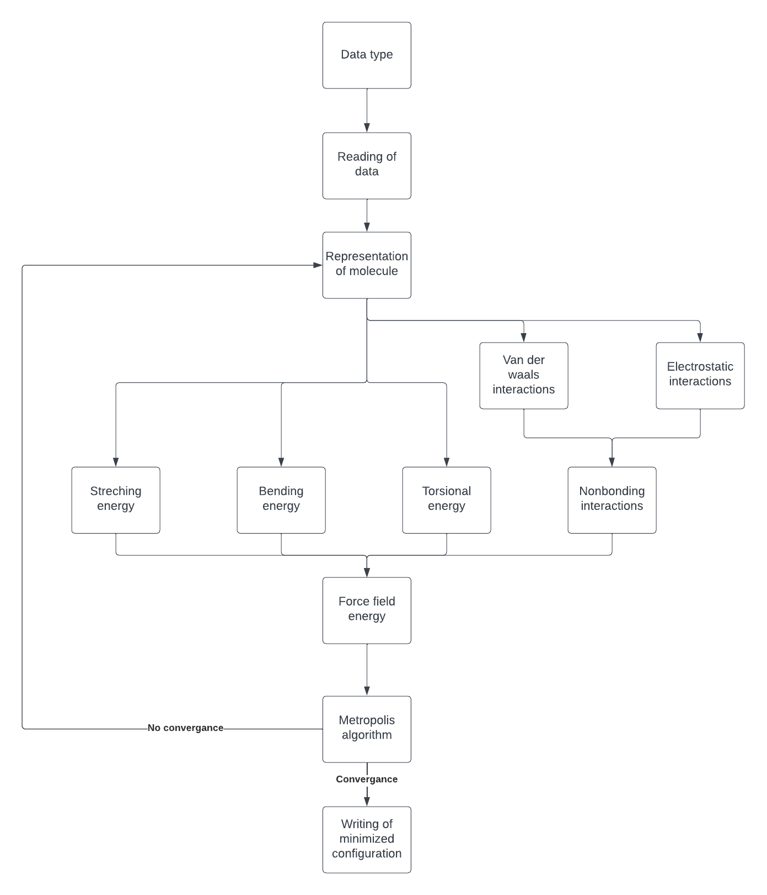

Data types:

type atom

! Setting the element in this project only C (carbon) or H (hydrogen)

character(1) :: element = 'E'

! The xyz coordinates of the atom in the molecule

real(realkind) :: x, y, z = 0.

end type

type bond

! Setting the indices of the atoms that are bonding

integer :: link(2) = 0

! Setting the type of bond in this project only CC or CH

character(2) :: type = 'EE'

! Setting the calculated distance of the bond in A

real(realkind) :: length = 0.

end type